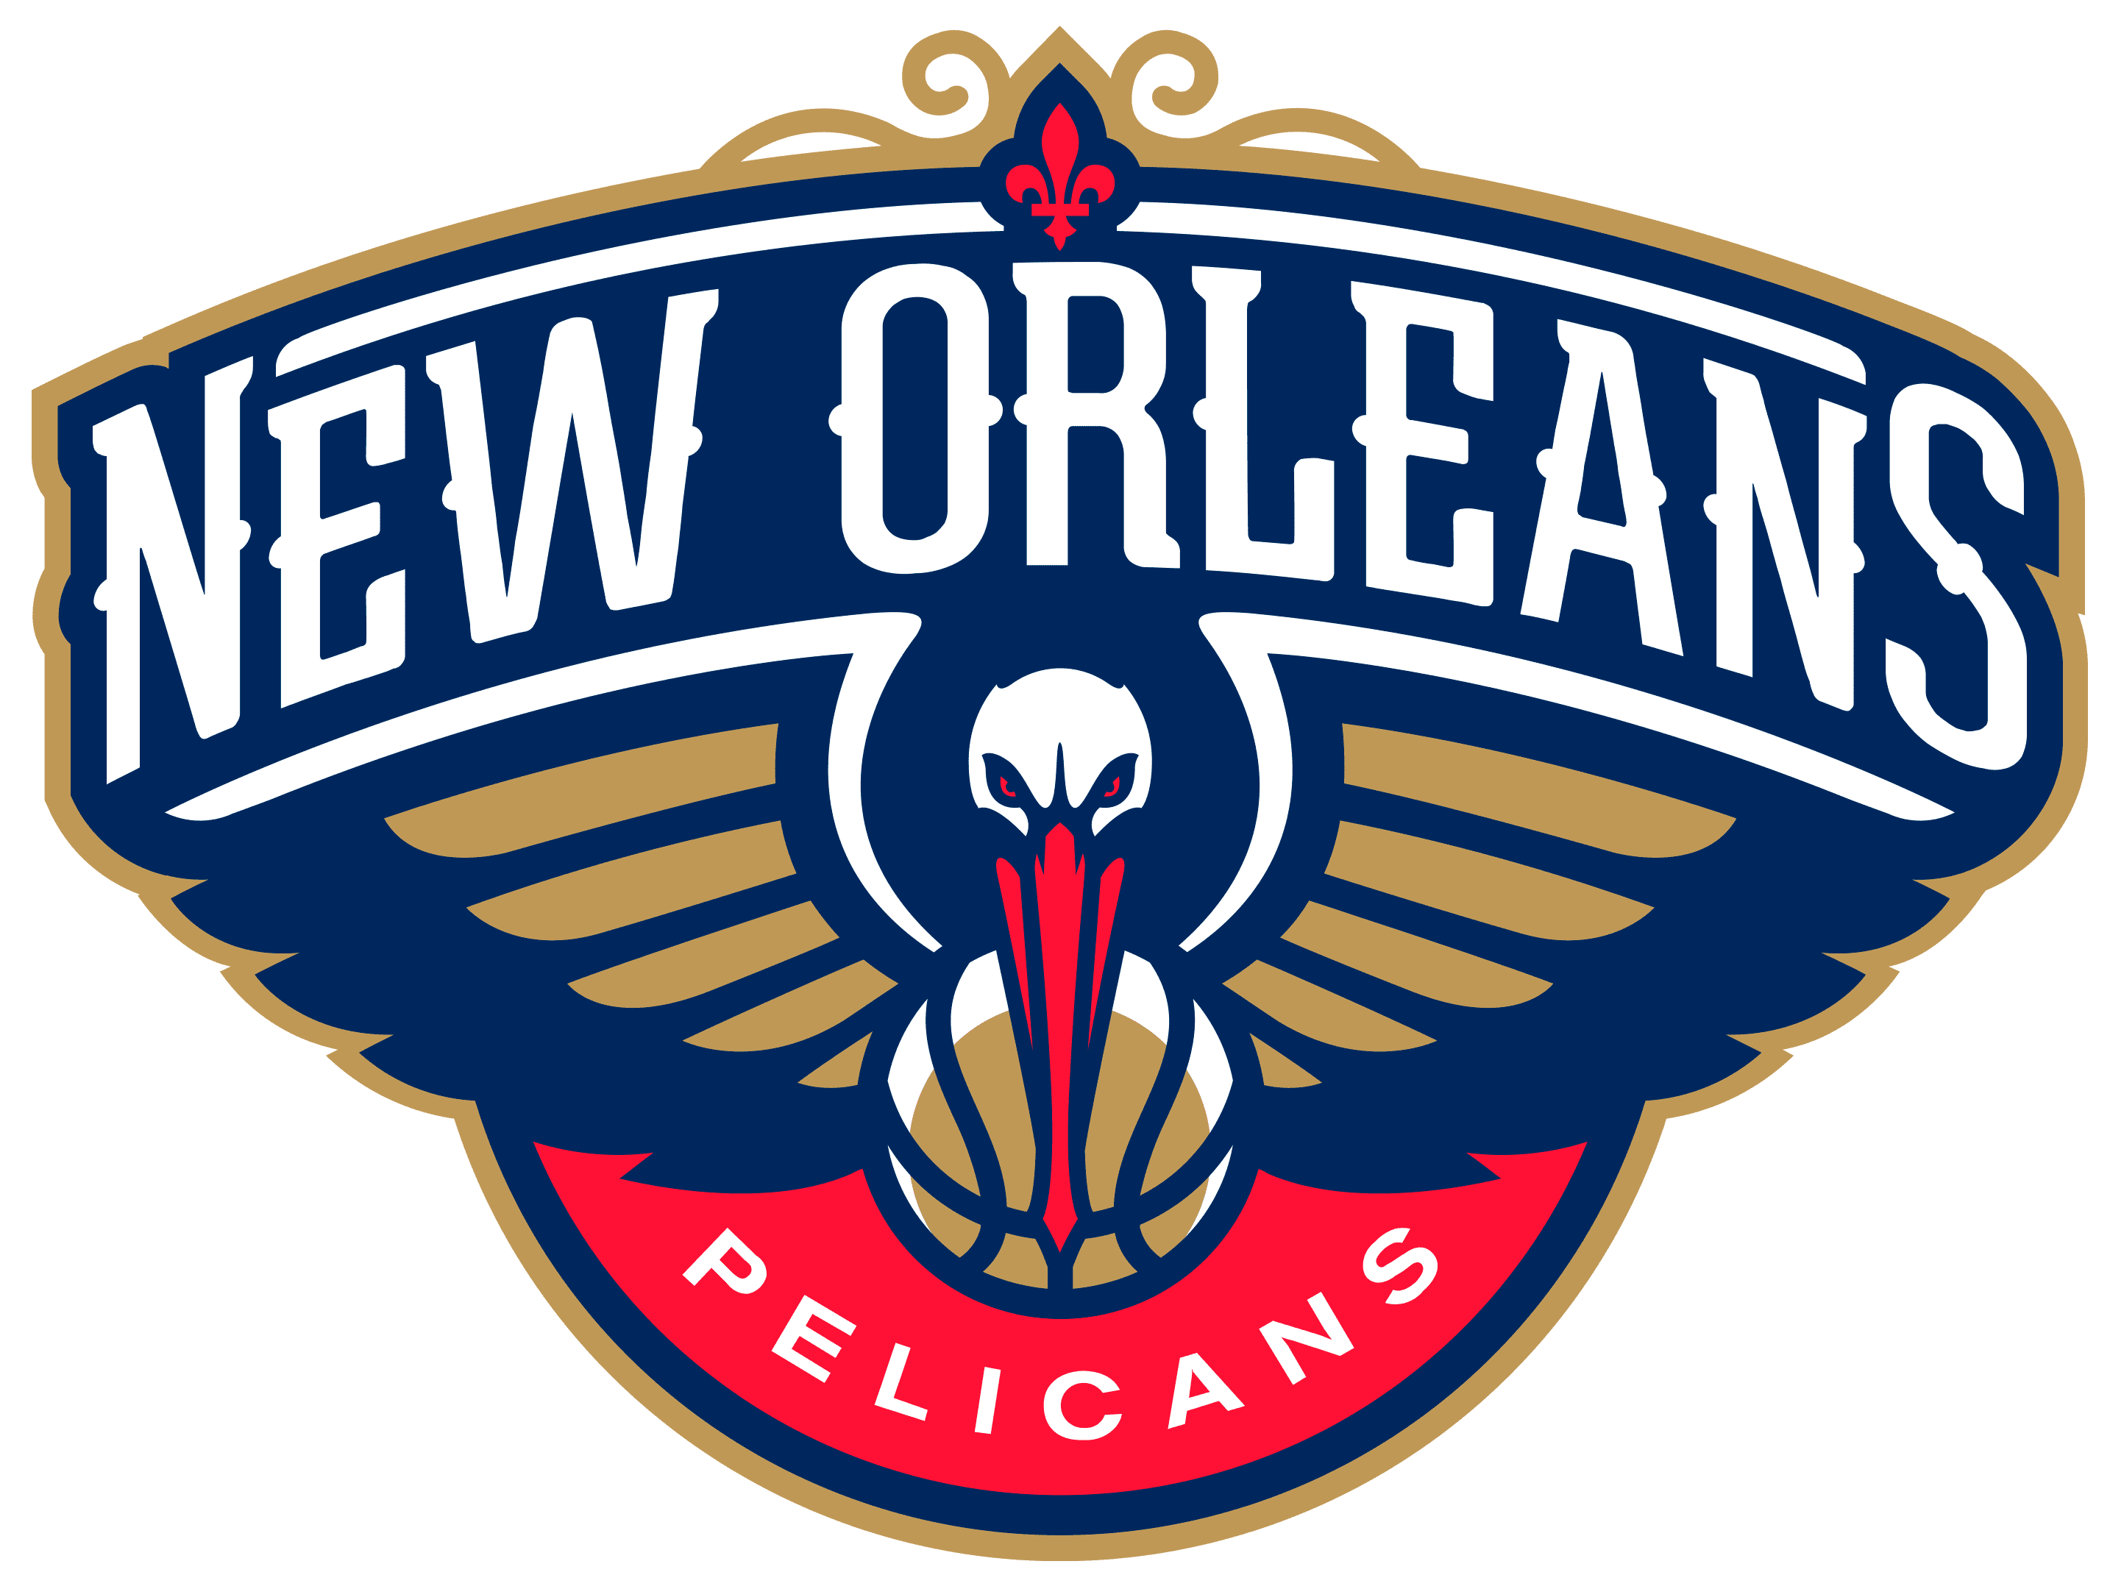
Mandeville High PTSA
Pelicans Night!

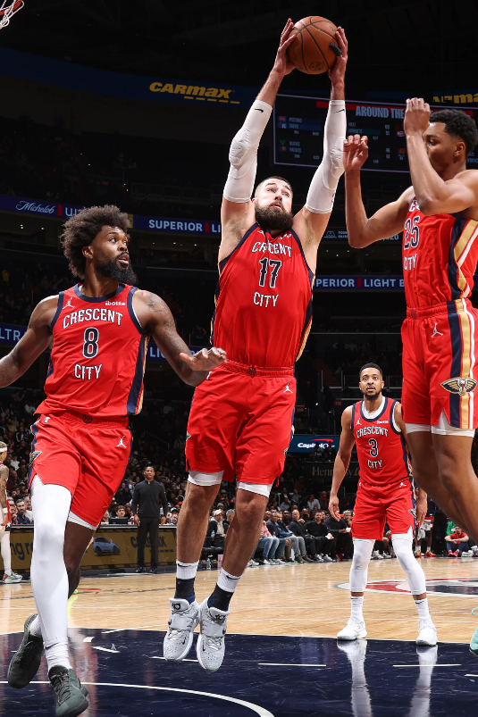
PELICANS v. THUNDER
Fri, January 26 @ 7pm
Deadline to Order: January 10

Come for a fun night out and watch the Pelicans take on the Thunder! The group will get the exciting opportunity to shoot a free throw on the court after the game at the Smoothie King Center! Tickets are open to everyone!
Go to Mandeville.CheddarUp.com to order.

Makes a

great present!
TICKETS: Tickets are $30 in the “Balcony End” location. View the seating chart online.
PARKING: An optional parking pass is $20.
ORDERING: Go to Mandeville.CheddarUp.com.
DEADLINE: Order before midnight on Wednesday, January 10.
DELIVERY: Sarah Gallaher will get your tickets to you by Jan 24.

Thank you for your tax-deductible donation!
MHS PTSA receives $5 for each ticket.
Questions? Email Sarah Gallaher at mhsptsa.pres@gmail.com.

