Coming Soon!
MJH PTA Color Run

The MJH PTA will host its first-ever Color Run on Thursday, October 3, 2019. This fun run will be a blast for the students as they walk, run, or dance through colored powder explosions with blaring dance music. The fundraiser kicks off on Monday, September 23, and runs through Thursday, October 3. After parents register at funrun.com, students collect flat donations (or pledges) to sponsor their run. As they raise more money for the MJH PTA, they earn more prizes! There’s even a prize just for registering! The entry level donation required to participate in the Color Run is $35.
GOAL: The MJH PTA Color Run Fundraiser has a goal of $20,000 with 90% of the proceeds (minus expenses) going to the MJH PTA. Profits will support Classroom Technology, the Student PBIS Program, and Teacher Spirit. We need our community’s support to reach our goal of $20,000! Start individual pledging now!

Early Pledging
9/18
Kick-Off Day
9/23
Color Run
10/3

Parents, go to funrun.com to register your student and start individual pledging as early as September 18! This is going to be so much fun!!!

Corporate Sponsor Sign Up
Deadline: September 20, 2019

I would like to participate at the following Sponsorship Level:
Double Platinum  $1500  Standalone Logo on  T-Shirt Sleeve & Banner | Platinum Level  $1000  Featured XL Logo on  T-Shirt & Banner | Gold Level  $500  Large Logo on  T-Shirt & Banner | Silver Level  $250  Medium Logo on  T-Shirt & Banner | Bronze Level  $125  Small Logo on  T-Shirt & Banner
All businesses are included on the Color Run t-shirt, large banner, and Eagle’s Nest newsletter.
Business
Address
Contact Name Contact Number
Email Address
Student/PE Teacher & Hour
Payment: CASH CHECK CREDIT CARD plus 3.25% Bank Fee. MJH PTA will call you.
All money given to the MJH PTA is tax-deductible. Enclosed is payment of $_____________

Please contact Beth Maillho at (985) 778-5799 or mjh.ptapres@gmail.com to register as a sponsor and to make sure we receive your information. Return the completed form with payment to the Madisonville Junior High office through a student or contact Beth Maillho. Email your high-resolution logo to mjh.ptapres@gmail.com.

**Deadline for sponsorships to be included on the t-shirts is September 20.**
MJH PTA Color Run
Today is Day 1 of the Best. Fundraiser. Ever!!!

The MJH PTA will have its first-ever Color Run on Thursday, October 3. This fun run will be a blast for the students as they walk, run, and dance through color powder explosions with blaring dance music. Parents first need to register the students at funrun.com. Students then collect flat donations or pledges from family, grandparents, neighbors, co-workers, etc., which are then logged online to sponsor their run. Pledges may be charged online, or cash or checks may be turned in at school. As they raise more money for MJH PTA, students earn cool prizes, hand-picked just for MJH! See page 2 for the complete list! The entry-level donation required to participate in the Color Run is $35 with the top prize level at $1500. There’s also a special “Eagle Angel” prize for students who generously sponsor another student at $35 allowing them to participate in the Color Run! There’s even a prize just for registering. Those without the ability to register online may send the paper registration on page 3 to school.

GOAL: The MJH PTA Color Run Fundraiser has a goal of $20,000 with 90% of the proceeds (minus expenses) going to the MJH PTA. Profits will support Classroom Technology, the Student PBIS Program, and Teacher Spirit. We need our community’s support to reach our goal of $20,000! Let’s make this the most successful fundraiser ever!

PE Class: This fundraiser is organized during the PE classes and will not take up any instructional time. Therefore, parents need the PE teacher’s name and period when they register their child at funrun.com. MJH PTA will spend 5-10 minutes daily during every PE class to handle collections, prize delivery, goal updates, and any special challenges. Students’ run times for the Color Run on October 3 will be during their regularly scheduled PE classes, except for 7th grade 4th hour whose run time is TBA. In case of bad weather, the rain-out date is scheduled for Monday, October 7.
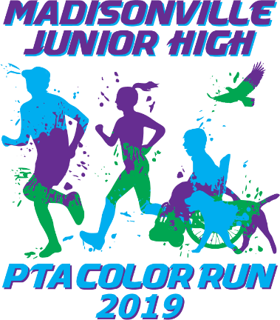
PARENTS are welcome to come and cheer for their students. Parent volunteers are needed to help with throwing the color powder (fun!) and organizing the event (still fun!). Come prepared to get powdered! Please note that the 7th hour parents will need to park south of Rampart St. so as not to impede the buses or car line.

Color Run details: On Thursday, October 3, students who have at least a $35 donation will receive a Color Run t-shirt and any other earned prizes, many of which may be worn during the run. When they go to their regular PE class, they will dress out in the Color Run t-shirt and regular PE shorts. Eye protection (sunglasses are a prize) and old shoes are encouraged. The students will go to the back field behind the gym with their class, and the Color Run will start immediately. Those students who are not participating in the Color Run will cheer on the students from under the big oak tree and enjoy the music. Parents will be placed at two or three stations around the two tracks where they will throw color on the students from the neck down at scheduled times during the run. Students may stay on the inside of the track if they wish to avoid the color powder. Once the run ends, students will go through the “de-powder zone” where they’ll be blown off with leaf blowers and given a plastic bag for their clothes. Please note that pledges are charged even if students are absent.

Medical Warning & Waiver: Parents, you know your children. Please consider if they have any medical conditions that might be complicated by this event, such as asthma, sensory sensitivities, or physical limitations, and decide what is best for them. The PTA is open to making accommodations. The color powder is a blend of 100% food-grade cornstarch, baking soda, and FDA and FD&C approved food and cosmetic dyes. It is non-toxic and biodegradable, and free of red dye #40 and tempura paint. All students are required to have parental approval with a signed waiver to participate, which is part of the registration process at funrun.com.

Questions? Contact Beth Maillho, MJH PTA President at (985) 778-5799 or mjh.ptapres@gmail.com, or Catherine Tully, MJH PTA Co-Pres at (985) 373-3871 or mjh.ptacopres@gmail.com.
this is going to be so much fun & benefit MJH!!!
Prize Schedule
The MJH PTA found some awesome cool prizes that the students will love! Many of the prizes can be worn or used during the Color Run, and the prizes are cumulative. For example, if a student raised $250, they would get the prizes starting with the Dum Dum and Smarties through the cowbell and “Front of the Line” Pass. Some of the prizes have a choice such as Level 4 and 8. And the top prize in Level Awesome has three color choices. Now let’s have some fun, Eagles!!!

Register at FunRun.com  Dum Dum & Smarties | Level 1: $35  T-Shirt & Shower Cap | Level 2: $70  Sunglasses & PE Dress-Out Pass
& | & | PE Dress Out Pass  &
Level 3: $110  Tube Socks & ID Pass | Level 4: $175  (Tutu or Cap) & Bathroom Pass | Level 5: $250  Cowbell & Front of Line Pass
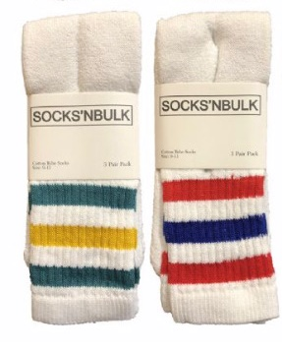  &  Free ID Pass | 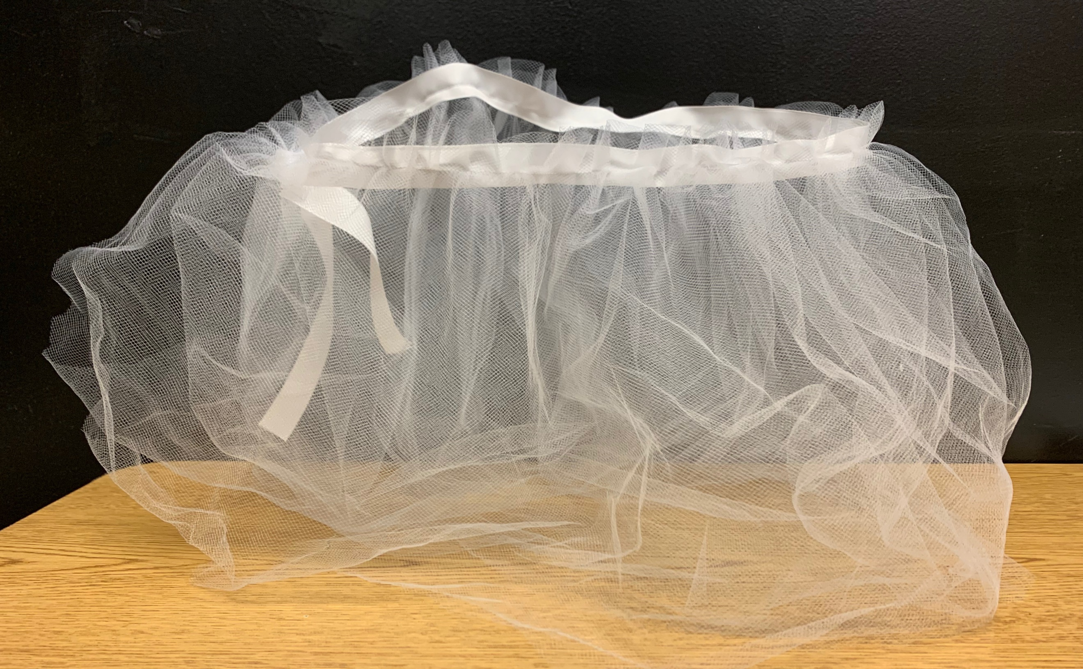  &  Bathroom Pass  or | Front of Line  in Cafeteria  &
Level 6: $350  Crazy White Wig | Level 7: $500  Bluetooth Sports Headphones | Level 8: $650  Tabletop Curling or Bowling Set
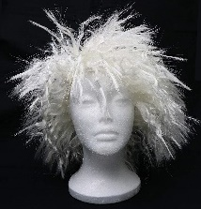 | 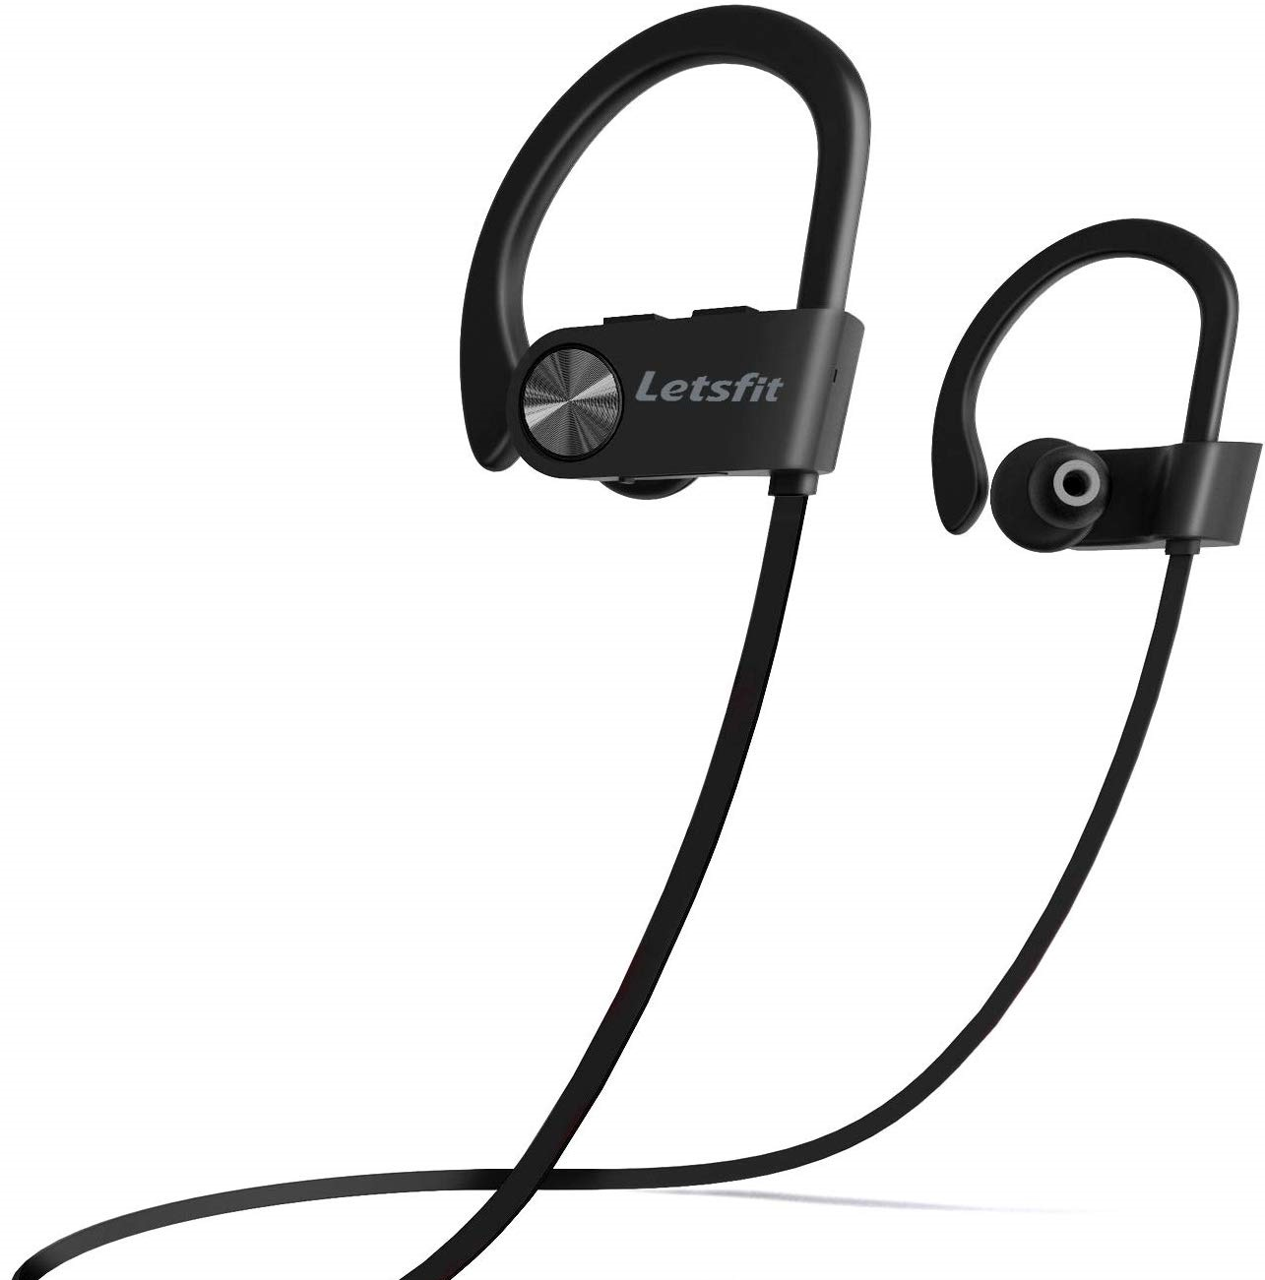  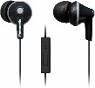 | 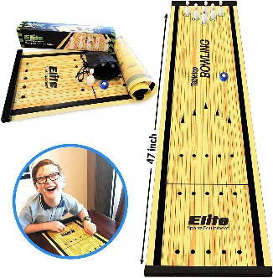  or
Level 9: $800  Waterproof Sports Camera | Level Fantastic: $1000  WiFi Drone with Camera | Level Awesome: $1500  Mongoose Expo Scooter
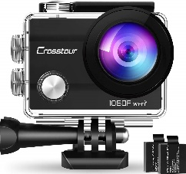 | 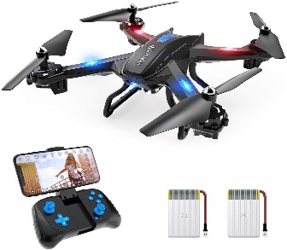 | 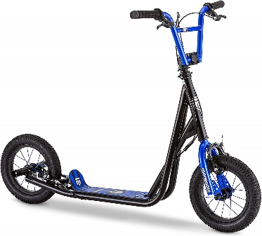
$35 Eagle Angel*  White Bandana | *Eagle Angel is a special prize for students who generously donate an additional $35 for another student to participate in the Color Run. To do this, first register a new student and use “Angel” in front of your student’s name. Then select “Eagle Angel” in 7th or 8th grade as the teacher. Contact the PTA if you want a particular student, or the PTA will randomly assign that registration to interested students in the designated grade. Contact Beth Maillho with questions at (985) 778-5799.
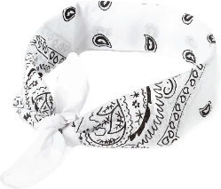
Volunteers Needed
Volunteers are needed daily during PE class and at the event on October 3. If you would like to volunteer and join in the fun, text or email Beth Maillho, MJH PTA President, at (985) 778-5799 or email mjh.ptapres@gmail.com. Please note that the bus parking area must be clear of cars by 1:30 PM on October 3. The 7th hour parents will need to park south of Rampart St. Any student check-outs will be handled as usual through the office.

Thank you, Sponsors!

$500 Gold Level
The Tully Family
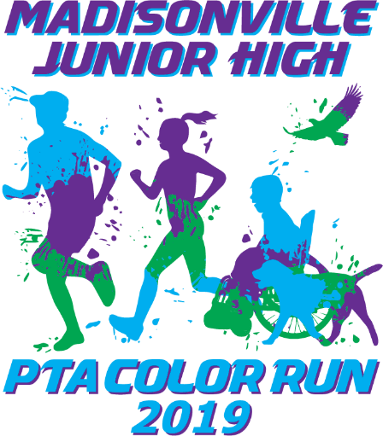
Dr. Kevin M. Plaisance
T-Shirt back
T-Shirt Front
Nielsen & Treas Law Firm
Beth Maillho, Matrix Realty

$250 Silver Level
Phone Doc
Five Guys Burgers and Fries
BridgeNet Technology Consultants
Dufrene Surveying & Engineering, Inc.

$125 Bronze Level
Ramrock School Supplies
Performance Chiropractic
Metairie Bank, Northshore
Smoothie King, Old Mandeville
Grace & Glamour, Doris Heckert

Paper Registration
Online registration at funrun.com is preferred, but those without internet access may register with this form. There is a $35 minimum for students to participate in the run. The required waiver will be sent to the parent to be signed. This information can also be emailed to Beth Maillho at mjh.ptapres@gmail.com.

7th 8th Jones Willie Mallory Thibodeaux
Student Name PE Period Grade Circle PE Teacher

Parent Name Phone Email

How would the parent like to receive the required waiver, if applicable? Email Text Paper copy sent home

$ Cash Check to MJH PTA Credit Card
Person Making Pledge Pledged Amount Form of Payment

$ Cash Check to MJH PTA Credit Card
Person Making Pledge Pledged Amount Form of Payment

$ Cash Check to MJH PTA Credit Card
Person Making Pledge Pledged Amount Form of Payment

